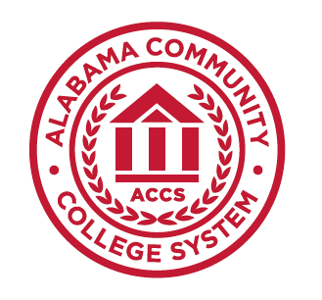
Alabama Community
College System

Course Number: SYS232
Course Title: Systems Modeling II

- System Modeling II — 3 Credit Hours

- Course Description

This is the second course in the three-course Systems Modeling sequence. It provides an increase in knowledge of the concepts of a system and systems modeling. It focuses on the more advanced concepts and tools necessary to generate a systems engineering (SE) model that represents a given system. Model documentation and the team approach to project management and execution are emphasized.

- Prerequisite/Corequisite
SYS101, SYS232

- Textbook and Course Support Materials
A Practical Guide to SysML, The Systems Modeling Language, 3/e, Friedenthal ISBN: 978-0-1 2-800202-5, Publisher: Morgan Kaufmann.
SysML Distilled, A brief Guide to The Systems Modeling Language, 1/e, Delligatti
ISBN: 978-0-321-92786-6, Publisher: Addison-Wesley

- Additional Resources
Systems Engineering with SysML/UML, Modeling, Analysis, Design;Tim Weilkiens

- Technical Requirements
You are required to have access to a computer (Windows Operating Systems (OS) that can be used to open, modify, and save files using the CAMEO modeling software and the ability to download and install programs on Windows OS.

- Course Learning Outcomes

By the end of the course, students will be able to:
  - Interpret a SysML model built using the extended feature set of SysML
  - Build a system engineering model using the extended feature set in SysML and the CAMEO tool
  - Utilize the CAMEO modeling tool to modify an existing SysML model of a given system developed using the extended feature set of SysML

- Course Outline of Topics

- Evaluation and Assessment

Grades will be given based upon A = 90 – 100%, B = 80 – 89%, C = 70 – 79%, D = 60 – 69%, and F = below 60%.

- Attendance

Determined by college unless stated otherwise.

- Statement on Discrimination/Harassment

It is the official policy of the Alabama Community College System and entities under its control, including all Colleges, that no person shall be discriminated against on the basis of any impermissible criterion or characteristic, including, without limitation, race, color, national origin, religion, marital status, disability, sex, age, or any other protected class as defined by federal and state law. (ACCS Policies 601.02 and 800.00)

- Americans with Disabilities

The Rehabilitation Act of 1973 (Section 504) and the Americans with Disabilities Act of 1990 state that qualified students with disabilities who meet the essential functions and academic requirements are entitled to reasonable accommodations. It is the student’s responsibility to provide appropriate disability documentation to the College.

