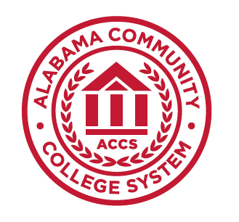
Alabama Community
College System

CIS 120
Google IT Professional Support I –
Technical Support Fundamentals

- Google IT Professional Support I Credit Hours 3
-Technical Support Fundamentals

- Course Description
- This course is one of five courses that make up the Google IT Technical Support certificate which prepares students to work as an entry-level IT Support Specialist. In this course, students will be introduced to the work of information technology. Students will learn about the different facets of information technology, such as computer hardware, the Internet, computer software, troubleshooting and customer service.

- Prerequisite: As Determined By College

- Textbook
Due to the varied selection of quality college-level textbooks, each college will select the textbook needed to meet the requirements of this course.

- Course Learning Outcomes

By the end of the course, students will be able to:
a) understand the binary system
b) assemble a computer
c) choose and install an operating system
d) utilize networks and the Internet
e) understand how applications are created and how they work
f) utilize common problem-solving methodologies and soft skills in an Information Technology setting

- Course Outline of Topics
Module A – Introduction To IT
- What is IT
- What does an IT Support Specialist do?
- The Path to Modern Computers
- Computer Language
- Character Encoding
- Binary
- How to Count in Binary
- Abstraction
- Computer Architecture Overview

Module B – Hardware
- Introduction to Computer Hardware
- Programs, the CPU, and Memory
- CPU
- RAM
- Motherboards
- Physical Storage: Hard Drives
- Power Supplies
- Mobile Devices
- Batteries and Charging Systems
- Peripherals and Ports
- BIOS
- Installing The Processor
- Adding the RAM And The Drive
- Adding Graphics and Other Peripherals
- Mobile Device

Module C – Operating System
- Components of an Operating System
- Files and File Systems
- Process Management
- Memory Management and Virtual Memory
- I/O Management
- Interacting with the OS: User Space
- Logs
- The Boot Process
- Mobile Operating Systems
- Choosing an Operating System
- Virtual Machines
- Installing Windows 10
- Installing Linux
- Chrome OS
- Mac OS

Module D - Networking
- Basics of Networking
- Networking Hardware
- TCP/IP
- The Web
- History of the Internet
- Limitations of the Internet
- Internet of Things
- Privacy and Security
- Impact of Internet

Module E – Software
- How software is built: Coding, scripting, and programming
- Types of Software
- Abstraction
- Managing Software
- Installing, Updating, and Removing Software on Windows
- Installing, Updating, and Removing Software on Linux

Module F- Troubleshooting
- Isolating the Problem
- Following the Cookie Crumbs
- Start with the Quickest Step First
- Troubleshooting Pitfalls to avoid
- Intro to Soft Skills
- How to Deal with Difficult Situations
- Ticketing Systems and Documenting Your Work
- Process Documentation
- Documenting in Ticketing Systems

