05/10/13

CAP 222

Specialization Field - Animation

Plan of Instruction

Effective Date: Spring 2013 Version Number: 2013-1

COURSE DESCRIPTION:

This course furthers the study of a particular field (modeling or animation) chosen by the student. Topics include (for modeling) digital sculpting, further anatomical study, understanding of muscle, fat and bone structure. Topics for animation include, learning of motion capture software, roto-capture and animation projects. Upon completion, the student should be able to showcase a deeper understanding of their chosen field.

CONTACT/CREDIT HOURS

Theory Credit Hours 1 hour
Lab Credit Hours 2 hours
Total Credit Hours 3 hours

NOTE: Theory credit hours are a 1:1 contact to credit ratio. Colleges may schedule lab hours as manipulative (3:1 contact to credit hour ratio) or experimental (2:1 contact to credit hour ratio).

PREREQUISITE COURSES

None

CO-REQUISITE COURSES

As determined by college.

PROFESSIONAL COMPETENCIES

- Explain the theoretical concepts in animation using motion capture.
- Implement advanced practical concepts in animation using motion capture.

INSTRUCTIONAL GOALS

- Cognitive – Comprehend principles and concepts related to advanced animation or modeling.

- Psychomotor – Apply principles of advanced animation or modeling.

- Affective – Value the importance of understanding advanced animation or modeling.

STUDENT OBJECTIVES

Condition Statement: Unless otherwise indicated, evaluation of student’s attainment of objectives is based on knowledge gained from this course. Specifications may be in the form of, but not limited to, cognitive skills diagnostic instruments, manufacturer’s specifications, technical orders, regulations, national and state codes, certification agencies, locally developed lab/clinical assignments, or any combination of specifications.

STUDENT LEARNING OUTCOMES

MODULE A – ANIMATION FIELD: MOTION CAPTURE THEORY
MODULE DESCRIPTION – This module instructs students on advanced notions relied to motion capture and CGI animation. Topics include animation techniques, CGI animation, motion capture industry requirements, motion capture software and workflow, and CGI character preparation.
PROFESSIONAL COMPETENCIES | PERFORMANCE OBJECTIVES | KSA
A1.0 Explain the theoretical concepts in animation using motion capture. | A1.1 This competency is measured cognitively. | 3
LEARNING OBJECTIVES |  | KSA
A1.1.1 Explain and identify the various techniques and styles of animation.  A1.1.2 Define various language terms for motion capture animation.  A1.1.3 Identify when roto-capture or motion capture is necessary.  A1.1.4 Explain how human movements can be transposed in CGI software.  A1.1.5 Explain the necessary steps in preparing a character for Motion capture animation. |  | 3  4  3  4  3
MODULE A OUTLINE:
- Animation techniques
- CGI animation
- Roto-capture
- Motion capture
- Motion capture pipeline industry- related requirements
- Games
- Films
- Overview of motion capture software and motion capture software workflow
- CGI character preparation

MODULE B – ANIMATION FIELD: MOTION CAPTURE SOFTWARE AND HARDWARE
MODULE DESCRIPTION – This module instructs students on advanced notions relied to motion capture and CGI animation. Topics include MotionBuilder user interface, characterization process, control rig, pose control, save keys, character settings, constraints, and a Motion Capture session using IPiSoft.
PROFESSIONAL COMPETENCIES | PERFORMANCE OBJECTIVES | KSA
A1.0 Implement advanced practical concepts in animation using motion capture. | A1.1 Utilize the various aspects of MotionBuilder to create a specified animated project. | 4
LEARNING OBJECTIVES |  | KSA
A1.1.1 Explain the history behind MotionBuilder.  A1.1.2 Describe the different navigation shortcuts in MotionBuilder.  A1.1.3 Describe the different ways to bring in elements in the software.  A1.1.4 Explain where to find and edit the properties for any elements.  A1.1.5 Explain and describe the characterization process.  A1.1.6 Explain why the naming convention is important.  A1.1.7 Describe how the skeletal structure should be built.  A1.1.8 Explain the difference between the A-pose and the T-Pose.  A1.1.9 Explain and describe the HumanIK rig.  A1.1.10 Describe the pose control tool.  A1.1.11 Explain and describe how to save keyframes in MotionBuilder.  A1.1.12 Explain the difference between Full body, Body Parts and Selection modes.  A1.1.13 Explain how to use the Characters settings page for animation retargeting.  A1.1.14 Explain the baking process from/to control rig or skeleton.  A1.1.15 Explain the motion capture process using IPiSoft.  A1.1.16 Describe the use of constraints and auxiliary pivots and effectors to modify animation.  A1.1.17 Explain how the filters can be use to clean up the motion curves  A1.1.18 Describe how to clean up the scene before exporting in software used for rendering.  A1.1.19 Explain what to save in the .fbx format for export.  A1.1.20 Explain how to work with multiple files. |  | 2  3  4  4  3  4  3  4  3  3  4  4  3  4  4  3  4  4  4  4
MODULE A OUTLINE:

- MotionBuilder history
- Motion builder user Interface
- Edit properties
- Preferences
- Navigation shortcuts
- Characterization process
- Naming convention
- Skeletal structure
- A-Pose vs T-Pose
- Control Rig
- Pose Control
- Save Keys
- Full Body
- Body Parts
- Selection
- Character Settings
- Retargeting Animation
- Baking Animation
- Constraints
- Motion Capture session using IPiSoft
- Capture
- Track Motion
- Export

LEARNING OUTCOMES Table of specifications
The table below identifies the percentage of learning objectives for each module. Instructors should develop sufficient numbers of test items at the appropriate level of evaluation.

 | Limited Knowledge and Proficiency | Moderate Knowledge and Proficiency | Advanced Knowledge and Proficiency | Superior Knowledge and Proficiency
KSA | 1 | 2 | 3 | 4
Module A |  |  | 60% | 40%
Module B |  | 5% | 35% | 60%

The KSA is NOT determined by the verb used in the learning objective, but rather in the context in which the verb is used and the depth of knowledge and skills required.

Example: Three KSA levels using the same verb (describe):
KSA 1 – Describe three characteristics of metamorphic rocks. (simple recall)
KSA 2 – Describe the difference between metamorphic and igneous rocks. (requires cognitive processing to determine the differences in the two rock types)
KSA 3 – Describe a model that you might use to represent the relationships that exist within the rock cycle. (requires deep understanding of rock cycle and a determination of how best to represent it)
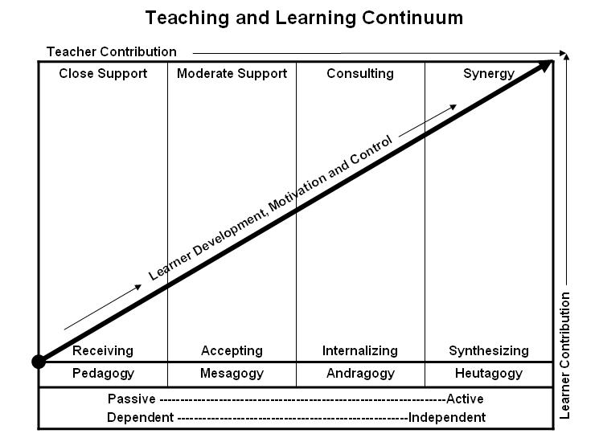
Learner’s Knowledge, Skills and Abilities
Indicator | Key Terms | Description
1 | Limited Knowledge and Proficiency | - Recognize basic information about the subject including terms and nomenclature.  - Students must demonstrate ability to recall information such as facts, terminology or rules related to information previously taught.  - Performs simple parts of the competency. Student requires close supervision when performing the competency.
2 | Moderate Knowledge and Proficiency | - Distinguish relationships between general principles and facts. Adopts prescribed methodologies and concepts.  - Students must demonstrate understanding of multiple facts and principles and their relationships, and differentiate between elements of information. Students state ideal sequence for performing task.  - Performs most parts of the competency with instructor assistance as appropriate.
3 | Advanced Knowledge and Proficiency | - Examines conditions, findings, or other relevant data to select an appropriate response.  - The ability to determine why and when a particular response is appropriate and predict anticipated outcomes.  - Students demonstrate their ability to seek additional information and incorporate new findings into the conclusion and justify their answers.  - Performs all parts of the competency without instructor assistance.
4 | Superior Knowledge and Proficiency | - Assessing conditions, findings, data, and relevant theory to formulate appropriate responses and develop procedures for situation resolution. Involves higher levels of cognitive reasoning.  - Requires students to formulate connections between relevant ideas and observations.  - Students apply judgments to the value of alternatives and select the most appropriate response.  - Can instruct others how to do the competency.  - Performs competency quickly and accurately.
A | Affective Objective | - Describes learning objectives that emphasize a feeling tone, an emotion, or a degree of acceptance or rejection.  - Objectives vary from simple attention to selected phenomena to complex but internally consistent qualities of character and conscience.  - Expressed as interests, attitudes, appreciations, values, and emotional sets or biases.

