05/10/13

CAP 203

Advanced Compositing

Plan of Instruction

Effective Date: Spring 2013 Version Number: 2013-1

COURSE DESCRIPTION:

This course furthers students’ study of compositing software and introduces visual effects design. Topics include color space, image transformation, tracking and film grain matching. Upon completion, the student should be able to perform intricate visual effects using images sequences and advanced tools

CONTACT/CREDIT HOURS

Theory Credit Hours 1 hour
Lab Credit Hours 2 hours
Total Credit Hours 3 hours

NOTE: Theory credit hours are a 1:1 contact to credit ratio. Colleges may schedule lab hours as manipulative (3:1 contact to credit hour ratio) or experimental (2:1 contact to credit hour ratio).

PREREQUISITE COURSES

CAP 102

CO-REQUISITE COURSES

As determined by college.

PROFESSIONAL COMPETENCIES
- Explain advanced concepts and tools used in compositing.
- Create complex layered visual effects.

INSTRUCTIONAL GOALS

- Cognitive – Comprehend principles and concepts related to complex images layering.

- Psychomotor – Apply principles of advanced compositing to create complex images layering.

- Affective – Value the importance of understanding color space and grain matching to create seamless layers integration.

STUDENT OBJECTIVES

Condition Statement: Unless otherwise indicated, evaluation of student’s attainment of objectives is based on knowledge gained from this course. Specifications may be in the form of, but not limited to, cognitive skills diagnostic instruments, manufacturer’s specifications, technical orders, regulations, national and state codes, certification agencies, locally developed lab/clinical assignments, or any combination of specifications.

STUDENT LEARNING OUTCOMES

MODULE A – REFINING THE COMPOSITING PROCESS
MODULE DESCRIPTION – This module instructs students on notions associated with advanced compositing. Topics include introduction to keying, general building blocks of a key, explanation of colors, file formats and keying tools, the importance of noise in compositing, the importance of edge treatment during the keying process, combining mattes, tracking 2D, and warping and morphing.
PROFESSIONAL COMPETENCIES | PERFORMANCE OBJECTIVES | KSA
A1.0 Explain advanced concepts and tools used in compositing. | A1.1 Assemble a sequence from an intricate source of images. | 3
LEARNING OBJECTIVES |  | KSA
A1.1.1 Define the different language terms for advanced compositing.  A1.1.2 Explain the concept of advance visual composition (Clean Plate, Key, 3D elements integration, Set extension).  A1.1.3 Discuss the different aspect of an advanced composition layout.  A1.1.4 Identify the source footage used (Cineon, Alexa, consumer camera...).  A1.1.5 Explain the necessary steps required for creating a complex composition (Key, tracking, noise, warping). |  | 3  3  3  4  4
MODULE A OUTLINE:
- Introduction to keying
- Blue or green screen
- General building blocks of a key
- Denoise
- Key
- Despill
- Explanation of colors, file formats and keying tools
- The importance of noise in compositing
- The importance of edge treatment during the keying process
- Combining mattes
- Soft keys
- Hard keys
- Tracking 2D (Image size to 2D coordinates)
- Warping and morphing

MODULE B – COLOR SPACE AND KEYING
MODULE DESCRIPTION – The purpose of this module is to teach the student detailed techniques to achieve complex layering used in the compositing process. Topics include overview of the footage, key, building the key, tracking 2D, and warping and morphing.
PROFESSIONAL COMPETENCIES | PERFORMANCE OBJECTIVES | KSA
B1.0 Create complex layered visual effects. | B1.1 Use Nuke to perform layer tracking operations. | 3
LEARNING OBJECTIVES |  | KSA
B1.1.1 Identify and explain the source footage encoding (file format and color space).  B1.1.2 Identify and analyze the various elements to consider in the source footage (Length, Motion Blur, Noise, Camera movement, Action).  B1.1.3 Identify the elements to key (green, blue, luma).  B1.1.4 Explain the pros and cons of the denoising process.  B1.1.5 Identify and explain the different keying tools (IBK, Primatte, KeyLight, keyer...).  B1.1.6 Explain what the core matte is.  B1.1.7 Explain where and when to use soft mattes.  B1.1.8 Experiment with various nodes to combine different mattes together (blur, edge blur, erode, channel merge).  B1.1.9 Explain why the viewer’s gamma and gain tools are useful while keying.  B1.1.10 Identify and describe the despill tools.  B1.1.11 Explain how to enhance edge details.  B1.1.12 Explain the grain matching process.  B1.1.13 Describe how 2D Tracking can help in compositing.  B1.1.14 Explain the different elements of the search boxes.  B1.1.15 Explain and describe the transformation modes in the tracking node.  B1.1.16 Explain and describe what a good tracking pattern is.  B1.1.17 Describe how to help the software to achieve a good track.  B1.1.18 Explain Warping and morphing source and destination images.  B1.1.19 Describe the keyframing process in morphing/warping.  B1.1.20 Explain the limitations of warping tools. |  | 3  4  3  3  2  4  3  2  3  4  3  3  4  4  3  3  3  4  3  3
MODULE B OUTLINE:
- Overview of the footage
  - Format
  - Color space
  - Length
  - Motion Blur
  - Noise
- Key
  - Analyse the screen color
  - Look at important elements (hair)
  - IBK color
  - IBK gizmo
  - Keymatte
  - Keyer
- Build the Key
  - Extract core matte
  - Mix in soft mattes
  - Despill
  - Comp background
  - Keymix edges
  - Match grain
- Tracking 2D
  - Tracking properties
  - Transform modes
  - Search boxes
  - 1,2 or 4 point tracking
  - Color correct before tracking
- Warping and Morphing
  - Source and destination
  - Animation

LEARNING OUTCOMES Table of specifications
The table below identifies the percentage of learning objectives for each module. Instructors should develop sufficient numbers of test items at the appropriate level of evaluation.

 | Limited Knowledge and Proficiency | Moderate Knowledge and Proficiency | Advanced Knowledge and Proficiency | Superior Knowledge and Proficiency
KSA | 1 | 2 | 3 | 4
Module A |  |  | 67% | 33%
Module B |  | 10% | 60% | 30%

The KSA is NOT determined by the verb used in the learning objective, but rather in the context in which the verb is used and the depth of knowledge and skills required.

Example: Three KSA levels using the same verb (describe):
KSA 1 – Describe three characteristics of metamorphic rocks. (simple recall)
KSA 2 – Describe the difference between metamorphic and igneous rocks. (requires cognitive processing to determine the differences in the two rock types)
KSA 3 – Describe a model that you might use to represent the relationships that exist within the rock cycle. (requires deep understanding of rock cycle and a determination of how best to represent it)

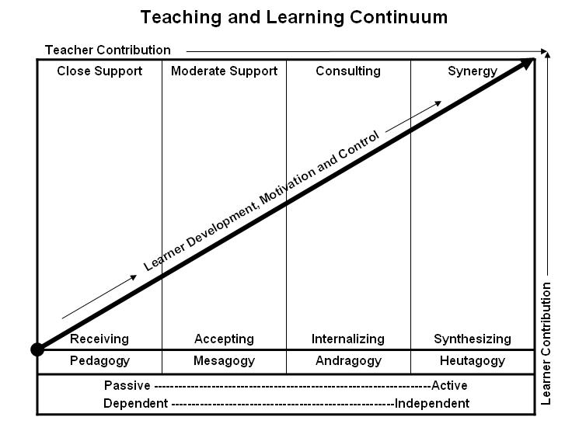
Learner’s Knowledge, Skills and Abilities
Indicator | Key Terms | Description
1 | Limited Knowledge and Proficiency | - Recognize basic information about the subject including terms and nomenclature.  - Students must demonstrate ability to recall information such as facts, terminology or rules related to information previously taught.  - Performs simple parts of the competency. Student requires close supervision when performing the competency.
2 | Moderate Knowledge and Proficiency | - Distinguish relationships between general principles and facts. Adopts prescribed methodologies and concepts.  - Students must demonstrate understanding of multiple facts and principles and their relationships, and differentiate between elements of information. Students state ideal sequence for performing task.  - Performs most parts of the competency with instructor assistance as appropriate.
3 | Advanced Knowledge and Proficiency | - Examines conditions, findings, or other relevant data to select an appropriate response.  - The ability to determine why and when a particular response is appropriate and predict anticipated outcomes.  - Students demonstrate their ability to seek additional information and incorporate new findings into the conclusion and justify their answers.  - Performs all parts of the competency without instructor assistance.
4 | Superior Knowledge and Proficiency | - Assessing conditions, findings, data, and relevant theory to formulate appropriate responses and develop procedures for situation resolution. Involves higher levels of cognitive reasoning.  - Requires students to formulate connections between relevant ideas and observations.  - Students apply judgments to the value of alternatives and select the most appropriate response.  - Can instruct others how to do the competency.  - Performs competency quickly and accurately.
A | Affective Objective | - Describes learning objectives that emphasize a feeling tone, an emotion, or a degree of acceptance or rejection.  - Objectives vary from simple attention to selected phenomena to complex but internally consistent qualities of character and conscience.  - Expressed as interests, attitudes, appreciations, values, and emotional sets or biases.

