05/10/13

CAP 202

Live Action and Integration Project
Plan of Instruction

Effective Date: Spring 2013 Version Number: 2013-1

COURSE DESCRIPTION:

This course introduces students to the principles of live action shooting for visual effects. Emphasis is placed on good pre-shoot planning and on how to avoid problematic situations. Topics include the study of camera tracking software and light matching techniques for the 3D elements. Upon completion the students should be able to shoot a live action plate, recreate a virtual matching camera and add CGI elements seamlessly.

CREDIT HOURS

Theory Credit Hours 2 hours
Lab Credit Hours 3 hours
Total Credit Hours 5 hours

NOTE: Theory credit hours are a 1:1 contact to credit ratio. Colleges may schedule lab hours as 3:1 and/or 2:1 contact to credit ratio. Clinical hours are 3:1 contact to credit ratio. (Ref Board Policy 705.01)

PREREQUISITE COURSES

CAP 122, CAP123

CO-REQUISITE COURSES

As determined by college.

PROFESSIONAL COMPETENCIES
- Explain how to reconstruct a virtual camera from a live sequence.
- Value the importance of a well planned pre-shoot
- Combine CGI and compositing skills to integrate seamless visual effects into live action sequence.

INSTRUCTIONAL GOALS

- Cognitive – Comprehend principles and concepts related to CGI integration into live action sequences.

- Psychomotor – Apply principles of CGI integration into live action sequences.

- Affective – Value the importance of adhering to policy and procedures related to CGI integration into live action sequences.

STUDENT OBJECTIVES

Condition Statement: Unless otherwise indicated, evaluation of student’s attainment of objectives is based on knowledge gained from this course. Specifications may be in the form of, but not limited to, cognitive skills diagnostic instruments, manufacturer’s specifications, technical orders, regulations, national and state codes, certification agencies, locally developed lab/clinical assignments, or any combination of specifications.

STUDENT LEARNING OUTCOMES

MODULE A – CAMERA TRACKING
MODULE DESCRIPTION – In this module the students are assisted in shooting live action elements and are instructed how to recreate virtual CGI camera from it. Topics include camera tracking, PFTrack, markers, 2D & 3D tracking, auto-tracking, object solver, photogrammetry, and shooting sequence project preparation.
PROFESSIONAL COMPETENCIES | PERFORMANCE OBJECTIVES | KSA
A1.0 Explain how to reconstruct a virtual camera from a live sequence. | A1.1 Demonstrate auto-tracking features. | 3
A2.0 Value the importance of a well planned pre-shoot. | A2.1 This competency is developed throughout this course. | A
LEARNING OBJECTIVES |  | KSA
A1.1.1 Describe how camera tracking is used in VFX sequences.  A1.1.2 Explain PFTrack Software main interface.  A1.1.3 Identify natural markers in a live sequence.  A1.1.4 Explain how to create an appropriate artificial marker for camera tracking.  A1.1.5 Differentiate between 2D tracking and 3D tracking.  A1.1.6 Describe the use of auto-tracking features.  A1.1.7 Explain object tracking inside a camera tracking.  A1.1.8 Describe what can be done using photogrammetry techniques.  A1.1.9 Explain how to prepare for a live action shoot. |  | 3  2  3  2  2  4  3  2  3
MODULE A OUTLINE:
- What is camera tracking
- PFTrack
- Markers
- 2D tracking
- 3D tracking
- Auto-Tracking
- Object solver
- Photogrammetry
- Shooting sequence project preparation

MODULE B – CGI INTEGRATION INTO LIVE ACTION
MODULE DESCRIPTION – This module guides the students during the creation of visual effects integration inside a live action sequence. Topics include concept and previz approval, live action shoot preparation, managing a work planning schedule, troubleshooting, third party expectations, project management and final presentation.
PROFESSIONAL COMPETENCIES | PERFORMANCE OBJECTIVES | KSA
B1.0 Combine CGI and compositing skills to integrate seamless visual effects into live action sequence. | B1.1 Create and revise a CGI project using live action sequence.  Samples of Behavior:  Present ideas clearly  Meet deadlines  Resolve problems  Revise project accordingly  Present project | 3
LEARNING OBJECTIVES |  | KSA
B1.1.1 Identify the processes related to the developing of a CGI project using live action.  B1.1.2 Describe the limitations dictated by a live action shoot.  B1.1.3 Discuss common techniques used to present ideas clearly.  B1.1.4 Describe techniques or tools used to schedule and work accordingly in order to meet deadlines.  B1.1.5 Describe techniques or tools used to resolve ongoing problems and revise project subsequently.  B1.1.6 Identify third party expectations and revise project consequently.  B1.1.7 Illustrate how to present a completed project adequately. |  | 3  3  2  3  3  3  3
MODULE B OUTLINE:

- Concept and previz approval
- Live action shoot preparation
- Managing a work planning schedule
- Troubleshooting
- Third party expectations
- Project management
- Final presentation

LEARNING OUTCOMES Table of specifications
The table below identifies the percentage of learning objectives for each module. Instructors should develop sufficient numbers of test items at the appropriate level of evaluation.

 | Limited Knowledge and Proficiency | Moderate Knowledge and Proficiency | Advanced Knowledge and Proficiency | Superior Knowledge and Proficiency
KSA | 1 | 2 | 3 | 4
Module A |  | 44% | 44% | 12%
Module B |  | 14% | 72% | 14%

The KSA is NOT determined by the verb used in the learning objective, but rather in the context in which the verb is used and the depth of knowledge and skills required.

Example: Three KSA levels using the same verb (describe):
KSA 1 – Describe three characteristics of metamorphic rocks. (simple recall)
KSA 2 – Describe the difference between metamorphic and igneous rocks. (requires cognitive processing to determine the differences in the two rock types)
KSA 3 – Describe a model that you might use to represent the relationships that exist within the rock cycle. (requires deep understanding of rock cycle and a determination of how best to represent it)

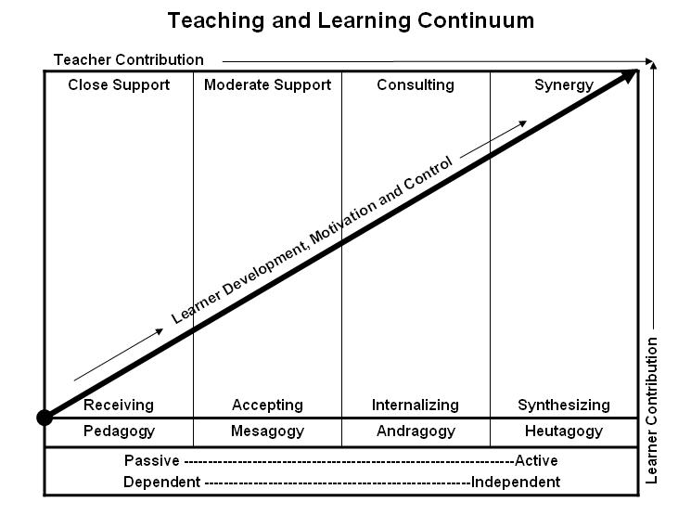
Learner’s Knowledge, Skills and Abilities
Indicator | Key Terms | Description
1 | Limited Knowledge and Proficiency | - Recognize basic information about the subject including terms and nomenclature.  - Students must demonstrate ability to recall information such as facts, terminology or rules related to information previously taught.  - Performs simple parts of the competency. Student requires close supervision when performing the competency.
2 | Moderate Knowledge and Proficiency | - Distinguish relationships between general principles and facts. Adopts prescribed methodologies and concepts.  - Students must demonstrate understanding of multiple facts and principles and their relationships, and differentiate between elements of information. Students state ideal sequence for performing task.  - Performs most parts of the competency with instructor assistance as appropriate.
3 | Advanced Knowledge and Proficiency | - Examines conditions, findings, or other relevant data to select an appropriate response.  - The ability to determine why and when a particular response is appropriate and predict anticipated outcomes.  - Students demonstrate their ability to seek additional information and incorporate new findings into the conclusion and justify their answers.  - Performs all parts of the competency without instructor assistance.
4 | Superior Knowledge and Proficiency | - Assessing conditions, findings, data, and relevant theory to formulate appropriate responses and develop procedures for situation resolution. Involves higher levels of cognitive reasoning.  - Requires students to formulate connections between relevant ideas and observations.  - Students apply judgments to the value of alternatives and select the most appropriate response.  - Can instruct others how to do the competency.  - Performs competency quickly and accurately.
A | Affective Objective | - Describes learning objectives that emphasize a feeling tone, an emotion, or a degree of acceptance or rejection.  - Objectives vary from simple attention to selected phenomena to complex but internally consistent qualities of character and conscience.  - Expressed as interests, attitudes, appreciations, values, and emotional sets or biases.

