March 25, 2013

CAP 201

Simulation and Particles Effects

Plan of Instruction

Effective Date: Spring 2013 Version Number: 2012-1

COURSE DESCRIPTION:

This course introduces students to the study of various physicals phenomenon and their simulated counterpart in the CGI world. Topics include particles systems workflow, forces, modifiers, typical effects and technological limitations. Upon completion the student should be able to reproduce and render a broad range of simulated physical phenomenon to enhance any visual effects sequence.

CREDIT HOURS

Theory Credit Hours 1 hour
Lab Credit Hours 2 hours
Total Credit Hours 3 hours

NOTE: Theory credit hours are a 1:1 contact to credit ratio. Colleges may schedule lab hours as 3:1 and/or 2:1 contact to credit ratio. Clinical hours are 3:1 contact to credit ratio. (Ref Board Policy 705.01)

PREREQUISITE COURSES

As determined by college.

CO-REQUISITE COURSES

As determined by college.

PROFESSIONAL COMPETENCIES
- Describe the workflow of particle systems and simulations.
- Use particles systems and simulation to reproduce physical phenomenon.
- Use volumetric shading to render particle systems.

INSTRUCTIONAL GOALS

- Cognitive – Comprehend principles and concepts related to particle systems and simulations.

- Psychomotor – Apply principles of simulation to visual effects using Softimage ICE system.

- Affective – Value the importance of observing real world phenomenon to recreate them with simulation software.

STUDENT OBJECTIVES

Condition Statement: Unless otherwise indicated, evaluation of student’s attainment of objectives is based on knowledge gained from this course. Specifications may be in the form of, but not limited to, cognitive skills diagnostic instruments, manufacturer’s specifications, technical orders, regulations, national and state codes, certification agencies, locally developed lab/clinical assignments, or any combination of specifications.

STUDENT LEARNING OUTCOMES

MODULE A – PARTICLE SYSTEM WORKFLOW – THE ICE WORK AREA
MODULE DESCRIPTION – This module instructs students on the particle system interface and its function nodes. Topics include the particle approximation paradigm, the nodal system, the particle life cycle, forces and environment, and the simulation port.
PROFESSIONAL COMPETENCIES | PERFORMANCE OBJECTIVES | KSA
A1.0 Describe the particle system interface and its function nodes. | A1.1 This competency is measured cognitively. | 2
LEARNING OBJECTIVES |  | KSA
A1.1.1 Explain how particles systems are used to represent natural phenomenon.  A1.1.2 Describe Softimage/ICE layout and interface.  A1.1.3 Identify basic node functionality.  A1.1.4 Describe how to create a basic particle emission.  A1.1.5 Describe particle behavior through events and triggers.  A1.1.6 Identify forces and their impact on particle behavior.  A1.1.7 Describe how to create particle obstacles.  A1.1.8 Explain the simulation port workflow. |  | 2  2  2  3  1  2  3  2
MODULE A OUTLINE:
- The particle approximation paradigm
- Shape, sprite or voxels
- The particle cloud
- The nodal system
- Types
- Connections and data formats
- Compounded nodes
- The particle life cycle
- Emission
- Birth parameters
- Triggers and events
- Death
- The forces and environment
- Local forces
- Global forces
- Collision
- The simulation port

MODULE B – CREATION OF TYPICAL PHENOMENON
MODULE DESCRIPTION – This module instructs students on various tools and the study of classic cases such as smoke, fire, rain and snow. Topics include emitters, particle rate and size, randomizers and turbulence, creating a system, collision, rendering sprites, and interaction with 3D elements.
PROFESSIONAL COMPETENCIES | PERFORMANCE OBJECTIVES | KSA
B1.0 Explain how to create typical particle simulations. | B1.1 Use particles systems and simulation to reproduce physical phenomenon. | 2
LEARNING OBJECTIVES |  | KSA
B1.1.1 Explain the emitter node parameters.  B1.1.2 Explain how to use randomizers and turbulence.  B1.1.3 Explore case study A (Typical: simulating smoke).  B1.1.4 Explore case study B (Collision: simulating rain).  B1.1.5 Explore case study C (Collision: simulating waterfall).  B1.1.6 Explore case study D (Using sprites: simulating snow).  B1.1.7 Explore case study E (Spawning: simulating sparks).  B1.1.8 Explore case study F (Moving emitter: fireball). |  | 2  2  3  2  2  2  2  3
MODULE B OUTLINE:
- Emitters
- Particle rate and size
- Randomizers and turbulence
- Creating a system
- Smoke
- Collision
- Rain
- Waterfall
- Rendering sprites
- Snow
- Interaction with 3D elements
- Fireball
- Sparks

MODULE C – SHADING AND RENDERING PARTICLE SYSTEM
MODULE DESCRIPTION – This module instruct about the use of volumetric rendering and its impact on rendering time. Topics include volumetric rendering and ray marching, and particle renderer node.
PROFESSIONAL COMPETENCIES | PERFORMANCE OBJECTIVES | KSA
C1.0 Describe how to use volumetric shaders to reproduce gaseous phenomenon. | C1.1 Use volumetric shading to render particle systems. | 2
LEARNING OBJECTIVES |  | KSA
C1.1.1 Explain what is ray marching.  C1.1.2 Describe the effect of the density parameters.  C1.1.3 Describe how to assign the particle cloud color  C1.1.4 Explain how to assign volume color.  C1.1.5 Define ray marching rendering parameters. |  | 1  2  3  2  2
MODULE C OUTLINE:
- Volumetric rendering and ray marching
- Particle renderer node
- Density
- Shape
- Falloff type
- Volume density
- Particle color
- Override
- Per cloud or gradient
- Volume color
- Ambience, diffuse and ambient occlusion
- Volume rendering
- Marching detail
- Shadow table
- Cell size

LEARNING OUTCOMES Table of specifications
The table below identifies the percentage of learning objectives for each module. Instructors should develop sufficient numbers of test items at the appropriate level of evaluation.

 | Limited Knowledge and Proficiency | Moderate Knowledge and Proficiency | Advanced Knowledge and Proficiency | Superior Knowledge and Proficiency
KSA | 1 | 2 | 3 | 4
Module A | 13% | 68% | 25%
Module B |  | 62% | 38%
Module C | 20% | 60% | 20%

The KSA is NOT determined by the verb used in the learning objective, but rather in the context in which the verb is used and the depth of knowledge and skills required.

Example: Three KSA levels using the same verb (describe):
KSA 1 – Describe three characteristics of metamorphic rocks. (simple recall)
KSA 2 – Describe the difference between metamorphic and igneous rocks. (requires cognitive processing to determine the differences in the two rock types)
KSA 3 – Describe a model that you might use to represent the relationships that exist within the rock cycle. (requires deep understanding of rock cycle and a determination of how best to represent it)

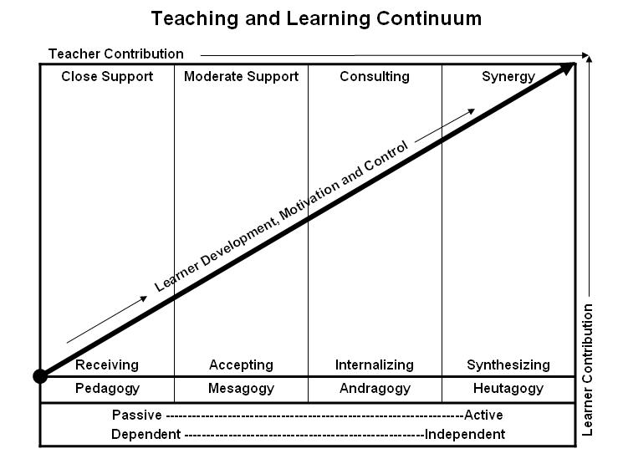
Learner’s Knowledge, Skills and Abilities
Indicator | Key Terms | Description
1 | Limited Knowledge and Proficiency | - Recognize basic information about the subject including terms and nomenclature.  - Students must demonstrate ability to recall information such as facts, terminology or rules related to information previously taught.  - Performs simple parts of the competency. Student requires close supervision when performing the competency.
2 | Moderate Knowledge and Proficiency | - Distinguish relationships between general principles and facts. Adopts prescribed methodologies and concepts.  - Students must demonstrate understanding of multiple facts and principles and their relationships, and differentiate between elements of information. Students state ideal sequence for performing task.  - Performs most parts of the competency with instructor assistance as appropriate.
3 | Advanced Knowledge and Proficiency | - Examines conditions, findings, or other relevant data to select an appropriate response.  - The ability to determine why and when a particular response is appropriate and predict anticipated outcomes.  - Students demonstrate their ability to seek additional information and incorporate new findings into the conclusion and justify their answers.  - Performs all parts of the competency without instructor assistance.
4 | Superior Knowledge and Proficiency | - Assessing conditions, findings, data, and relevant theory to formulate appropriate responses and develop procedures for situation resolution. Involves higher levels of cognitive reasoning.  - Requires students to formulate connections between relevant ideas and observations.  - Students apply judgments to the value of alternatives and select the most appropriate response.  - Can instruct others how to do the competency.  - Performs competency quickly and accurately.
A | Affective Objective | - Describes learning objectives that emphasize a feeling tone, an emotion, or a degree of acceptance or rejection.  - Objectives vary from simple attention to selected phenomena to complex but internally consistent qualities of character and conscience.  - Expressed as interests, attitudes, appreciations, values, and emotional sets or biases.

