November 21, 2012

CAP 123

CGI Shading, Lighting and Rendering

Plan of Instruction

Effective Date: Spring 2013 Version Number: 2013-1

COURSE DESCRIPTION:

This course introduces students to the mechanics of how various materials react to light in real life and in a CGI software. Topics include study of various shaders, lighting techniques and rendering parameters. Upon completion the student should be able to reproduce common object surface and render them efficiently.

CONTACT/CREDIT HOURS

Theory Credit Hours 1 hour
Lab Credit Hours 2 hours
Total Credit Hours 3 hours

NOTE: Theory credit hours are a 1:1 contact to credit ratio. Colleges may schedule lab hours as manipulative (3:1 contact to credit hour ratio) or experimental (2:1 contact to credit hour ratio).

PREREQUISITE COURSES

As determined by college.

CO-REQUISITE COURSES

As determined by college.

PROFESSIONAL COMPETENCIES
- Discuss the purpose of photorealism in Art and in CGI.
- Use a CGI software to create photorealistic rendering.

INSTRUCTIONAL GOALS

- Cognitive – Comprehend principles and concepts related to shading.

- Psychomotor – Apply principles of shading to create realistic render.

- Affective – Value the importance of emulating real life object surface in a CGI Software.

STUDENT OBJECTIVES

Condition Statement: Unless otherwise indicated, evaluation of student’s attainment of objectives is based on knowledge gained from this course. Specifications may be in the form of, but not limited to, cognitive skills diagnostic instruments, manufacturer’s specifications, technical orders, regulations, national and state codes, certification agencies, locally developed lab/clinical assignments, or any combination of specifications.

STUDENT LEARNING OUTCOMES

MODULE A – PHOTOREALISM
MODULE DESCRIPTION – This module instructs students on theories relative to photorealistic rendering. Topics include photorealism in Arts, lights and surface in the real world.
PROFESSIONAL COMPETENCIES | PERFORMANCE OBJECTIVES | KSA
A1.0 Discuss the purpose of photorealism in Art and in CGI. | A1.1 This competency is measured cognitively. | 2
LEARNING OBJECTIVES |  | KSA
A1.1.1 Examine the differences and relationships between image, reality and symbolism.  A1.1.2 Identify Art periods and genres leading to photorealism.  A1.1.3 Define both (particle and wavelength) models used in physics to represent light phenomena.  A1.1.4 Explain the black body theory.  A1.1.5 Explain how light temperature affects photography.  A1.1.6 Explain the need of photorealism in CGI productions.  A1.1.7 Define how CGI shaders emulate real world. |  | 1  2  2  2  3  3  2
MODULE A OUTLINE:
- Photorealism
- Image, reality and symbolism
- Art genres leading to photorealism
- The relation between light and surfaces in the real world
  - The black body theory.
  - Light temperature
- Photorealism in CGI

MODULE B – LIGHTING AND SHADING WITH MENTAL RAY.TM
MODULE DESCRIPTION – The purpose of this module is to teach the student on creation of various surfaces of common objects. Topics include shading solutions, HDR application and the bitmap texture paradigm.
PROFESSIONAL COMPETENCIES | PERFORMANCE OBJECTIVES | KSA
B1.0 Use Softimage to create 3D objects. | B1.1 Output renderings from created objects. | 2
LEARNING OBJECTIVES |  | KSA
B1.1.1 Identify various light paths in a shader.  B1.1.2 Explain diffused light in an illumination shader.  B1.1.3 Explain the provenance of a specular component.  B1.1.4 Identify the various type of lights in Softimage.  B1.1.5 Explain the difference between ray traced light and area lights.  B1.1.6 Describe sky shader.  B1.1.7 Describe how to activate final gathering.  B1.1.8 Describe how to activate global illumination.  B1.1.9 Explain caustic light mode.  B1.1.10 Explain how to take a picture to create an HDR file.  B1.1.11 Describe how to assemble an HDR file in Photoshop.  B1.1.12 Describe Architectural node overview.  B1.1.13 Explain reflective materials.  B1.1.14 Describe metallic surface properties.  B1.1.15 Explain how to add roughness to surface with bump mapping.  B1.1.16 Explain anisotropic reflections.  B1.1.17 Describe transparent surface properties.  B1.1.18 Explain the refraction index and its use.  B1.1.19 Describe what is sub-surface scattering.  B1.1.20 Explain translucency properties.  B1.1.21 Describe how to add multiple materials to a single object.  B1.1.22 Identify bit mapping problems and solutions.  B1.1.23 Explain Mip mapping mode.  B1.1.24 Explain the differences between bitmap texture mapping and procedural (fractal) texture mapping. |  | 1  2  3  3  3  2  2  2  2  2  3  1  3  3  2  1  3  2  2  3  3  2  3  2
MODULE B OUTLINE:
- Lighting and shading with Mental Ray.
- Light interpretation in CGI.
  - Diffuse
  - Specular
  - Transmitted
- CGI lights
  - Raytraced
  - Area light
  - Sky shaders
- Radiosity algorithm
  - Final gathering
  - Global illumination
- HDR file creation and use in CGI software
- Architectural shader from Mental Images.
  - Reflectives surface
  - Metallic surface
  - Surface roughness
  - Anosotropic reflections
  - Transparent surface
  - Refraction index
- Sub-Surface scattering
- Muti-material on single geometry
- Texture resolution: problems and solution
  - Mip mapping
  - Procedural textures

LEARNING OUTCOMES Table of specifications
The table below identifies the percentage of learning objectives for each module. Instructors should develop sufficient numbers of test items at the appropriate level of evaluation.

 | Limited Knowledge and Proficiency | Moderate Knowledge and Proficiency | Advanced Knowledge and Proficiency | Superior Knowledge and Proficiency
 | 1 | 2 | 3 | 4
Module A | 14% | 57% | 29%
Module B | 12% | 46% | 42%

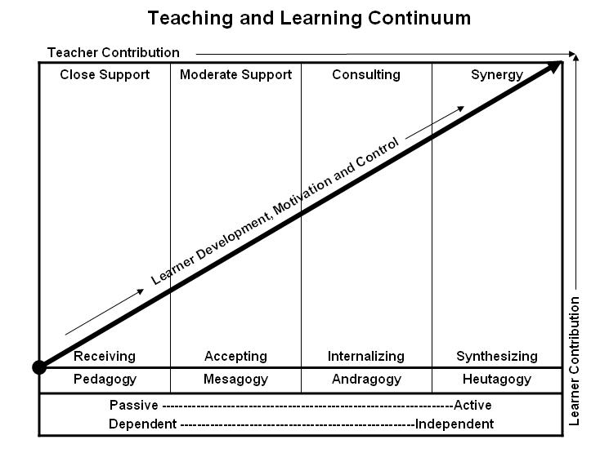

Learner’s Knowledge, Skills and Abilities
Indicator | Key Terms | Description
1 | Limited Knowledge and Proficiency | - Recognize basic information about the subject including terms and nomenclature.  - Students must demonstrate ability to recall information such as facts, terminology or rules related to information previously taught.  - Performs simple parts of the competency. Student requires close supervision when performing the competency.
2 | Moderate Knowledge and Proficiency | - Distinguish relationships between general principles and facts. Adopts prescribed methodologies and concepts.  - Students must demonstrate understanding of multiple facts and principles and their relationships, and differentiate between elements of information. Students state ideal sequence for performing task.  - Performs most parts of the competency with instructor assistance as appropriate.
3 | Advanced Knowledge and Proficiency | - Examines conditions, findings, or other relevant data to select an appropriate response.  - The ability to determine why and when a particular response is appropriate and predict anticipated outcomes.  - Students demonstrate their ability to seek additional information and incorporate new findings into the conclusion and justify their answers.  - Performs all parts of the competency without instructor assistance.
4 | Superior Knowledge and Proficiency | - Assessing conditions, findings, data, and relevant theory to formulate appropriate responses and develop procedures for situation resolution. Involves higher levels of cognitive reasoning.  - Requires students to formulate connections between relevant ideas and observations.  - Students apply judgments to the value of alternatives and select the most appropriate response.  - Can instruct others how to do the competency.  - Performs competency quickly and accurately.
A | Affective Objective | - Describes learning objectives that emphasize a feeling tone, an emotion, or a degree of acceptance or rejection.  - Objectives vary from simple attention to selected phenomena to complex but internally consistent qualities of character and conscience.  - Expressed as interests, attitudes, appreciations, values, and emotional sets or biases.

