05/10/13

CAP 122

Storytelling and Previzualisation Process/Project
Plan of Instruction

Effective Date: Spring 2013 Version Number: 2013-1

COURSE DESCRIPTION:

This course introduces students to the storytelling and previzualisation process. Topics include use of tools like storyboard, rough 3d animation, camera framing and the importance of timing in storytelling. Upon completion, the student should be able to use these tools to prepare for the creation of a full CGI animated short feature.

CREDIT HOURS

Theory Credit Hours 2 hours
Lab Credit Hours 3 hours
Total Credit Hours 5 hours

NOTE: Theory credit hours are a 1:1 contact to credit ratio. Colleges may schedule lab hours as 3:1 and/or 2:1 contact to credit ratio. Clinical hours are 3:1 contact to credit ratio. (Ref Board Policy 705.01)

PREREQUISITE COURSES

CAP 101

CO-REQUISITE COURSES

As determined by college.

PROFESSIONAL COMPETENCIES
- Comprehend the workflow of breaking down a story into short cue frames.
- Value the importance using storyboard and animatic to convey a story.
- Utilize CGI creation skills in an animation project.

INSTRUCTIONAL GOALS

- Cognitive – Comprehend principles and concepts related to previzualisation.

- Psychomotor – Apply principles of previzualisation to CGI animation creation.

- Affective – Value the importance of adhering to policy and procedures related to previzualisation to create coherent CGI animated stories.

STUDENT OBJECTIVES

Condition Statement: Unless otherwise indicated, evaluation of student’s attainment of objectives is based on knowledge gained from this course. Specifications may be in the form of, but not limited to, cognitive skills diagnostic instruments, manufacturer’s specifications, technical orders, regulations, national and state codes, certification agencies, locally developed lab/clinical assignments, or any combination of specifications.

STUDENT LEARNING OUTCOMES

MODULE A – PREVIZUALISATION
MODULE DESCRIPTION – This module instructs students on tools and practices relative to pre-production steps. Topics include pre-production processes, storyboards, camera, timing and storytelling, and previzualisation tools.
PROFESSIONAL COMPETENCIES | PERFORMANCE OBJECTIVES | KSA
A1.0 Comprehend the workflow of breaking down a story into short cue frames. | A1.1 This competency is measured cognitively. | 3
A2.0 Value the importance using storyboard and animatic to convey a story. | A2.1 This competency is developed throughout the course. | A
LEARNING OBJECTIVES |  | KSA
A1.1.1 Explain what is the purpose of the pre-production stages.  A1.1.2 Describe what a storyboard is and how to read it.  A1.1.3 Describe the camera language.  A1.1.4 Explain the importance of camera motion and framing.  A1.1.5 Explain how various shot durations and transitions affect the storytelling flow.  A1.1.6 Identify key elements in a script to help maintain storyboard coherence.  A1.1.7 Experiment with CGI animation to create animated storyboards (animatic).  A1.1.8 Explain how the previzualisation shortens the ensuing CGI process.  A1.1.9 Explore a famous movie sequence storyboard and its final cinematographic rendition. |  | 3  3  3  3  2  2  3  3  2
MODULE A OUTLINE:
- Pre-production process
- Storyboards
- Camera, timing and storytelling
- From script to images
- CGI animatic
- Why do we need previzualisation
- Case study (Jurassic Park sequence: dinosaurs introduction to lead actor)

MODULE B – CGI PROJECT
MODULE DESCRIPTION – The purpose of this module is to teach the student to utilize CGI creation skills in an animation project. Topics include concept and previz approval, managing a work planning schedule, troubleshooting, third party expectations, project management, and final presentation.
PROFESSIONAL COMPETENCIES | PERFORMANCE OBJECTIVES | KSA
B1.0 Utilize CGI creation skills in an animation project. | B1.1 Create and revise a CGI project.  Samples of Behavior:  Present ideas clearly  Meet deadlines  Resolve problems  Revise project accordingly  Present project | 3
B1.0 Utilize CGI creation skills in an animation project. | B1.2 Perform operations necessary to render a CGI project. | 3
LEARNING OBJECTIVES |  | KSA
B1.1.1 Identify the necessary processes related to the developing of a CGI project.  B1.1.2 Discuss common techniques used to present ideas clearly.  B1.1.3 Describe techniques or tools used to schedule and work accordingly in order to meet deadlines.  B1.1.4 Describe techniques or tools used to resolve ongoing problems and revise project subsequently.  B1.1.5 Identify third party expectations and revise project consequently.  B1.1.6 Illustrate how to present a completed project adequately. |  | 3  3  2  2  2  3
B1.2.1 Define the various procedures for manipulating and managing a  completed project. |  | 3
MODULE B OUTLINE:
- Concept and previz approval
- Managing a work planning schedule
- Troubleshooting
- Third party expectations
- Project management
- Final presentation

LEARNING OUTCOMES Table of specifications
The table below identifies the percentage of learning objectives for each module. Instructors should develop sufficient numbers of test items at the appropriate level of evaluation.

 | Limited Knowledge and Proficiency | Moderate Knowledge and Proficiency | Advanced Knowledge and Proficiency | Superior Knowledge and Proficiency
KSA | 1 | 2 | 3 | 4
Module A |  | 33% | 67%
Module B |  | 43% | 57%

The KSA is NOT determined by the verb used in the learning objective, but rather in the context in which the verb is used and the depth of knowledge and skills required.

Example: Three KSA levels using the same verb (describe):
KSA 1 – Describe three characteristics of metamorphic rocks. (simple recall)
KSA 2 – Describe the difference between metamorphic and igneous rocks. (requires cognitive processing to determine the differences in the two rock types)
KSA 3 – Describe a model that you might use to represent the relationships that exist within the rock cycle. (requires deep understanding of rock cycle and a determination of how best to represent it)

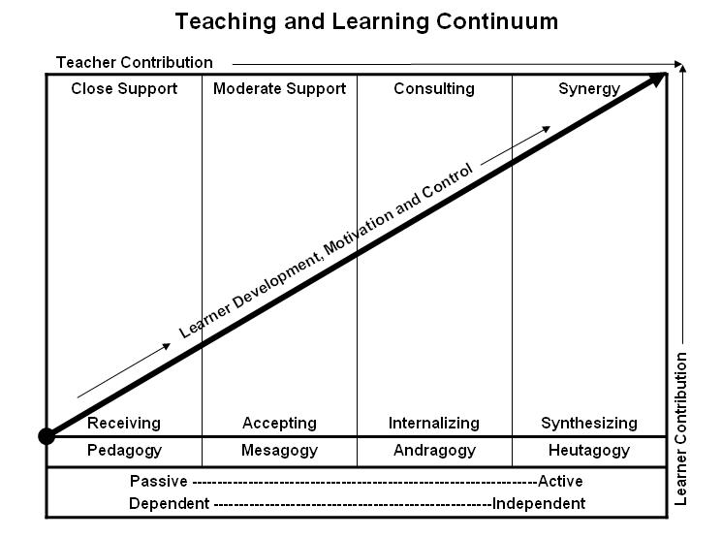
Learner’s Knowledge, Skills and Abilities
Indicator | Key Terms | Description
1 | Limited Knowledge and Proficiency | - Recognize basic information about the subject including terms and nomenclature.  - Students must demonstrate ability to recall information such as facts, terminology or rules related to information previously taught.  - Performs simple parts of the competency. Student requires close supervision when performing the competency.
2 | Moderate Knowledge and Proficiency | - Distinguish relationships between general principles and facts. Adopts prescribed methodologies and concepts.  - Students must demonstrate understanding of multiple facts and principles and their relationships, and differentiate between elements of information. Students state ideal sequence for performing task.  - Performs most parts of the competency with instructor assistance as appropriate.
3 | Advanced Knowledge and Proficiency | - Examines conditions, findings, or other relevant data to select an appropriate response.  - The ability to determine why and when a particular response is appropriate and predict anticipated outcomes.  - Students demonstrate their ability to seek additional information and incorporate new findings into the conclusion and justify their answers.  - Performs all parts of the competency without instructor assistance.
4 | Superior Knowledge and Proficiency | - Assessing conditions, findings, data, and relevant theory to formulate appropriate responses and develop procedures for situation resolution. Involves higher levels of cognitive reasoning.  - Requires students to formulate connections between relevant ideas and observations.  - Students apply judgments to the value of alternatives and select the most appropriate response.  - Can instruct others how to do the competency.  - Performs competency quickly and accurately.
A | Affective Objective | - Describes learning objectives that emphasize a feeling tone, an emotion, or a degree of acceptance or rejection.  - Objectives vary from simple attention to selected phenomena to complex but internally consistent qualities of character and conscience.  - Expressed as interests, attitudes, appreciations, values, and emotional sets or biases.

