05/10/13

CAP 121

CGI Animation
Plan of Instruction

Effective Date: Spring 2013 Version Number: 2013-1

COURSE DESCRIPTION:

This course introduces students to character animation principles and a study of advanced CGI techniques. Topics include animation principles, keyframing, rigging, skinning and UV texturing. Upon completion, students should be able to rig a CGI character properly and apply various animations to it.

CREDIT HOURS

Theory Credit Hours 2 hours
Lab Credit Hours 1 hour
Total Credit Hours 3 hours

NOTE: Theory credit hours are a 1:1 contact to credit ratio. Colleges may schedule lab hours as 3:1 and/or 2:1 contact to credit ratio. Clinical hours are 3:1 contact to credit ratio. (Ref Board Policy 705.01)

PREREQUISITE COURSES

CAP 101

CO-REQUISITE COURSES

As determined by college.

PROFESSIONAL COMPETENCIES
- Comprehend the theoretical aspects of character animation.
- Comprehend the technical steps used in keyframing and key editing in a CGI Software.
- Define the motion range of a CGI character when creating an animation rig.

INSTRUCTIONAL GOALS

- Cognitive – Comprehend principles and concepts related to CGI character animation.

- Psychomotor – Apply principles of CGI character animation.

- Affective – Value the importance of motion range when creating CGI character animation.

STUDENT OBJECTIVES

Condition Statement: Unless otherwise indicated, evaluation of student’s attainment of objectives is based on knowledge gained from this course. Specifications may be in the form of, but not limited to, cognitive skills diagnostic instruments, manufacturer’s specifications, technical orders, regulations, national and state codes, certification agencies, locally developed lab/clinical assignments, or any combination of specifications.

STUDENT LEARNING OUTCOMES

MODULE A – CGI ANIMATION TECHNIQUES
MODULE DESCRIPTION – This module instructs students on various animation techniques and styles. Topics include animation principles, language and terms, software integration, and character setup.
PROFESSIONAL COMPETENCIES | PERFORMANCE OBJECTIVES | KSA
A1.0 Comprehend the theoretical aspects of character animation. | A1.1 This competency is measured cognitively. | 3
LEARNING OBJECTIVES |  | KSA
A1.1.1 Explain and identify the various techniques and styles of animation.  A1.1.2 List the principles of animation.  A1.1.3 Explain and identify the various aspects of animation.  A1.1.4 Define various language terms for animation and rigging.  A1.1.5 Explain how principles of animation can be transposed in CGI software.  A1.1.6 Explain the necessary steps needed to prepare a character for animation. |  | 2  3  3  3  2  3
MODULE A OUTLINE:
- Animation techniques
- Stop Motion
- 2D cell animation
- 3D animation
- Animation principles
- Language and terms used in animation
- Software integration
- Character setup

MODULE B – CGI CHARACTER ANIMATION WORFLOW
MODULE DESCRIPTION – This module instructs students on various steps related to CGI character animation. Topics include simple characters, keyframing, human character rigging, creating character skin, using controllers, and an animation case study.
PROFESSIONAL COMPETENCIES | PERFORMANCE OBJECTIVES | KSA
B1.0 Comprehend the technical steps used in keyframing and key editing in a CGI Software. | B1.1 Define the motion range of a CGI character when creating an animation rig. | 3
LEARNING OBJECTIVES |  | KSA
B1.1.1 Identify the shape of the subject to animate.  B1.1.2 Explain the various considerations when rigging a character for animation.  B1.1.3 Explain the importance of hierarchical animation and rigging.  B1.1.4 Describe how to create a controlling object (or controller).  B1.1.5 Explain and describe the different spline animation curves.  B1.1.6 Explain and identify key frames and f-curves in animation editor  B1.1.7 Describe how the Dopesheet and Animation editor can be used to modify animation.  B1.1.8 Explain how to apply animation principles on character.  B1.1.9 Explain how to create a chain bone rig.  B1.1.10 List the different elements of a chain bone rig.  B1.1.11 Describe how to create and connect the chain bones in a human figure.  B1.1.12 Differentiate Inverse Kinematic and Forward Kinematic animation.  B1.1.13 Describe the Construction history modes.  B1.1.14 Explain and describe the skinning process  B1.1.15 Explain and describe how to create animation controllers.  B1.1.16 Differentiate Global and Local kinematics.  B1.1.17 List various keyframing techniques (Multiple, autokey)  B1.1.18 Explain the difference between pose to pose animation and straight forward animation.  B1.1.19 Describe how shape animation can help with the skinning deformation. |  | 3  2  4  3  3  3  2  3  4  3  3  2  4  3  3  3  3  3  3
MODULE B OUTLINE:
- Simple character (bouncing ball)
- Shape analysis
- The rigging process
- Keyframing
- Timing
- Animation curve
  - linear
  - constant
  - spline
- Dopesheet or animation editor to modify animation
- Apply animation principles to character
- Human character rigging
- Creating character skin
- Add envelope operator in animation construction stack
- Save Default pose
- Use the paint skinning tools
- Use mirror weight tool
- Using controllers
- Create controllers using curves
- Use constraints to control chain bones
- Rename and put colors on controllers
- Set character key set
- Animation case study
- Creating a walk cycle
- Add shape animation to fix problems or add details

LEARNING OUTCOMES Table of specifications
The table below identifies the percentage of learning objectives for each module. Instructors should develop sufficient numbers of test items at the appropriate level of evaluation.

 | Limited Knowledge and Proficiency | Moderate Knowledge and Proficiency | Advanced Knowledge and Proficiency | Superior Knowledge and Proficiency
KSA | 1 | 2 | 3 | 4
Module A |  | 33% | 67%
Module B |  | 16% | 68% | 16%

The KSA is NOT determined by the verb used in the learning objective, but rather in the context in which the verb is used and the depth of knowledge and skills required.

Example: Three KSA levels using the same verb (describe):
KSA 1 – Describe three characteristics of metamorphic rocks. (Simple recall)
KSA 2 – Describe the difference between metamorphic and igneous rocks. (requires cognitive processing to determine the differences in the two rock types)
KSA 3 – Describe a model that you might use to represent the relationships that exist within the rock cycle. (requires deep understanding of rock cycle and a determination of how best to represent it)

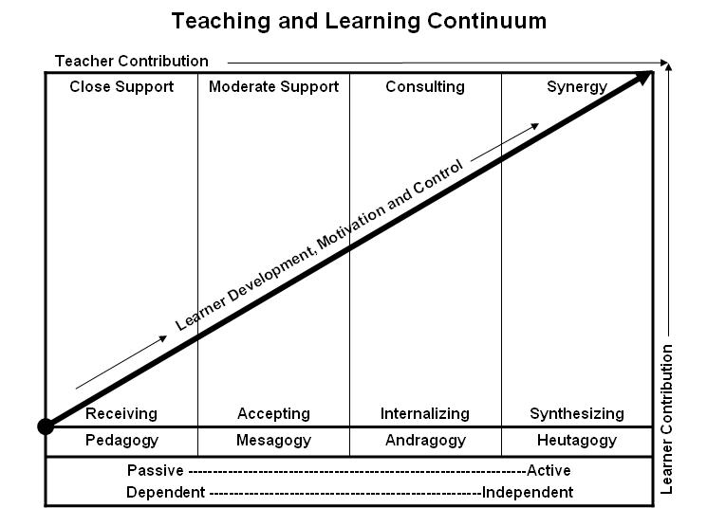
Learner’s Knowledge, Skills and Abilities
Indicator | Key Terms | Description
1 | Limited Knowledge and Proficiency | - Recognize basic information about the subject including terms and nomenclature.  - Students must demonstrate ability to recall information such as facts, terminology or rules related to information previously taught.  - Performs simple parts of the competency. Student requires close supervision when performing the competency.
2 | Moderate Knowledge and Proficiency | - Distinguish relationships between general principles and facts. Adopts prescribed methodologies and concepts.  - Students must demonstrate understanding of multiple facts and principles and their relationships, and differentiate between elements of information. Students state ideal sequence for performing task.  - Performs most parts of the competency with instructor assistance as appropriate.
3 | Advanced Knowledge and Proficiency | - Examines conditions, findings, or other relevant data to select an appropriate response.  - The ability to determine why and when a particular response is appropriate and predict anticipated outcomes.  - Students demonstrate their ability to seek additional information and incorporate new findings into the conclusion and justify their answers.  - Performs all parts of the competency without instructor assistance.
4 | Superior Knowledge and Proficiency | - Assessing conditions, findings, data, and relevant theory to formulate appropriate responses and develop procedures for situation resolution. Involves higher levels of cognitive reasoning.  - Requires students to formulate connections between relevant ideas and observations.  - Students apply judgments to the value of alternatives and select the most appropriate response.  - Can instruct others how to do the competency.  - Performs competency quickly and accurately.
A | Affective Objective | - Describes learning objectives that emphasize a feeling tone, an emotion, or a degree of acceptance or rejection.  - Objectives vary from simple attention to selected phenomena to complex but internally consistent qualities of character and conscience.  - Expressed as interests, attitudes, appreciations, values, and emotional sets or biases.

