November 14, 2012

CAP 102

Compositing Basics

Plan of Instruction

Effective Date: Spring 2013 Version Number: 2013-1

COURSE DESCRIPTION:
This course covers the fundamentals aspects of compositing software. Various techniques are covered such color correction, layering, rotoscoping and color screen extraction. Upon completion, students should be able to integrate images from various sources to create a seamless visual effects sequence.

CONTACT/CREDIT HOURS

Theory Credit Hours 1 hour
Lab Credit Hours 2 hours
Total Credit Hours 3 hours

NOTE: Theory credit hours are a 1:1 contact to credit ratio. Colleges may schedule lab hours as manipulative (3:1 contact to credit hour ratio) or experimental (2:1 contact to credit hour ratio).

PREREQUISITE COURSES

As determined by college.

CO-REQUISITE COURSES

As determined by college.

PROFESSIONAL COMPETENCIES
- Explain the purpose of compositing in a CGI production pipeline.
- Use compositing software to layer images in a correct form.

INSTRUCTIONAL GOALS

- Cognitive – Comprehend principles and concepts related to composting.

- Psychomotor – Apply principles of compositing to create intricate visual effects sequences.

- Affective – Value the importance of mixing adequate source material (live, CGI, 2D) to create complete visual effects sequence.

STUDENT OBJECTIVES

Condition Statement: Unless otherwise indicated, evaluation of student’s attainment of objectives is based on knowledge gained from this course. Specifications may be in the form of, but not limited to, cognitive skills diagnostic instruments, manufacturer’s specifications, technical orders, regulations, national and state codes, certification agencies, locally developed lab/clinical assignments, or any combination of specifications.

STUDENT LEARNING OUTCOMES

MODULE A – UNDERSTANDING COMPOSITING
MODULE DESCRIPTION – This module instructs students on theories relative to photorealistic rendering. Topics include photorealism in Arts, lights and surface in the real world.
PROFESSIONAL COMPETENCIES | PERFORMANCE OBJECTIVES | KSA
A1.0 Explain the purpose of compositing in a CGI production pipeline. | A1.1 This competency is measured cognitively. | 3
LEARNING OBJECTIVES |  | KSA
A1.1.1 Identify the different language terms in compositing.  A1.1.2 Explain the concept of visual composition.  A1.1.3 Identify and explain the different elements used in a composition.  A1.1.4 Identify the source of the elements used (3D render, Film footage).  A1.1.5 Explain the aspect of creating a composition for the different mediums (TV, film).  A1.1.6 Explain the necessary steps in creating a composition. |  | 1  2  3  3  3  2
MODULE A OUTLINE:
- Compositing
- Language and vocabulary of compositing
- Elements and principles of compositing
- Composition formats
  - Film
  - Television
  - Mobile
- Steps taken for compositing
- Final composition

MODULE B – THE NODE NETWORK IN NUKE
MODULE DESCRIPTION – The purpose of this module is to teach the student how to create various surfaces of common objects. Topics include shading solutions, HDR application and the bitmap texture paradigm.
PROFESSIONAL COMPETENCIES | PERFORMANCE OBJECTIVES | KSA
B1.0 Use Nuke to create basic to average node compositing network. | B1.1 Output sequences to create visual effects. | 2
LEARNING OBJECTIVES |  | KSA
B1.1.1 Identify the various elements: viewer, properties bin, nodes graph, nodes pane.  B1.1.2 Explain the interaction between them (properties, graph and viewer).  B1.1.3 Describe and differentiate between a node based application and a layer based application.  B1.1.4 Identify and explain what a Node is.  B1.1.5 Identify image file formats and colour space.  B1.1.6 Define and explain the project settings.  B1.1.7 Explain the various considerations when deciding what resolution to use.  B1.1.8 Describe how to set your program preferences for optimal use.  B1.1.9 Identify and explain the different options in the viewer settings.  B1.1.10 Describe how to navigate in the node graph and viewer.  B1.1.11 Explain how image modes and color selection affect the image/sequence.  B1.1.12 Explain the various considerations when dealing with 8bit or 16bit images.  B1.1.13 Explain why components, layers and channels are essential within Nuke.  B1.1.14 Identify and describe pre-multiplied image from non pre-multiplied image.  B1.1.15 Identify and explain the use of filters and various filter effects.  B1.1.16 Identify and explain the importance of bounding box.  B1.1.17 Identify and describe the different filters in the transform nodes.  B1.1.18 Identify and describe the appropriate tools for painting and roto-ing.  B1.1.19 Explain how to save keyframes.  B1.1.20 Identify and explain the Dopesheet and curve editor.  B1.1.21 Define and explain Render to Flipbook.  B1.1.22 Explain what cache is and how to clean it up.  B1.1.23 Explain the importance of saving data in the appropriate formats.  B1.1.24 Explain how to render an image sequence to disk |  | 2  1  2  3  2  3  2  1  2  3  2  2  2  3  3  2  3  2  3  2  3  3  2  3
MODULE B OUTLINE:
- The node network in Nuke

- Reading Images in Nuke
  - Different ways to bring in images and sequences
  - Reading the image type (bit depth, matte, resolution...)
  - Setting the project settings (resolution, frame rate...)
  - Saving the project
- Combining (layering) images
  - Different compositing operations give different look
  - how to quickly apply good colour correction (dark and bright spots)
  - How to deal with premultiplied vs un-premultiplied images in Nuke
  - How manipulate an image around
  - How to save keys to animate
- Testing out the results
  - Render in memory (flipbook)
  - Adjust the playback
  - Scroll frame by frame
- Render out to disk
  - Get a write node
  - Specify a path and a file name
  - File format and compression
  - Frame range
  - Render

LEARNING OUTCOMES Table of specifications
The table below identifies the percentage of learning objectives for each module. Instructors should develop sufficient numbers of test items at the appropriate level of evaluation.

 | Limited Knowledge and Proficiency | Moderate Knowledge and Proficiency | Advanced Knowledge and Proficiency | Superior Knowledge and Proficiency
 | 1 | 2 | 3 | 4
Module A | 17% | 33% | 50%
Module B | 8% | 50% | 42%

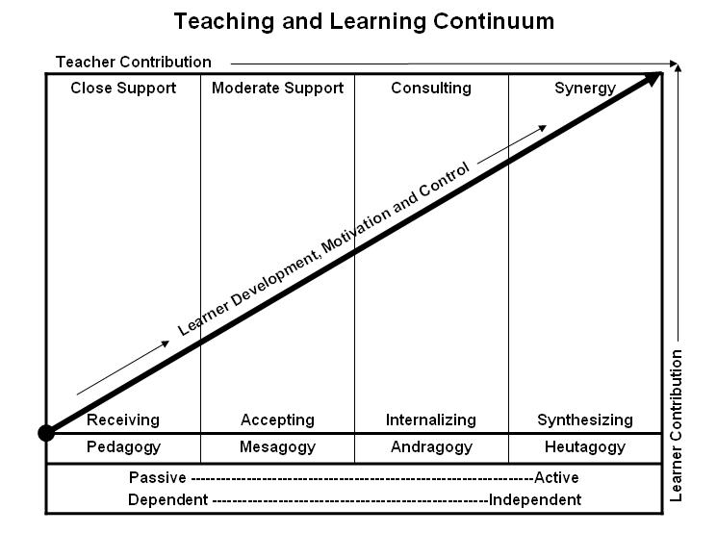

Learner’s Knowledge, Skills and Abilities
Indicator | Key Terms | Description
1 | Limited Knowledge and Proficiency | - Recognize basic information about the subject including terms and nomenclature.  - Students must demonstrate ability to recall information such as facts, terminology or rules related to information previously taught.  - Performs simple parts of the competency. Student requires close supervision when performing the competency.
2 | Moderate Knowledge and Proficiency | - Distinguish relationships between general principles and facts. Adopts prescribed methodologies and concepts.  - Students must demonstrate understanding of multiple facts and principles and their relationships, and differentiate between elements of information. Students state ideal sequence for performing task.  - Performs most parts of the competency with instructor assistance as appropriate.
3 | Advanced Knowledge and Proficiency | - Examines conditions, findings, or other relevant data to select an appropriate response.  - The ability to determine why and when a particular response is appropriate and predict anticipated outcomes.  - Students demonstrate their ability to seek additional information and incorporate new findings into the conclusion and justify their answers.  - Performs all parts of the competency without instructor assistance.
4 | Superior Knowledge and Proficiency | - Assessing conditions, findings, data, and relevant theory to formulate appropriate responses and develop procedures for situation resolution. Involves higher levels of cognitive reasoning.  - Requires students to formulate connections between relevant ideas and observations.  - Students apply judgments to the value of alternatives and select the most appropriate response.  - Can instruct others how to do the competency.  - Performs competency quickly and accurately.
A | Affective Objective | - Describes learning objectives that emphasize a feeling tone, an emotion, or a degree of acceptance or rejection.  - Objectives vary from simple attention to selected phenomena to complex but internally consistent qualities of character and conscience.  - Expressed as interests, attitudes, appreciations, values, and emotional sets or biases.

