November 14, 2012

CAP 101

Computer Graphics Software Basics

Plan of Instruction

Effective Date: Fall 2012 Version Number: 2012-1

COURSE DESCRIPTION:
This course introduces students to Computer Graphic Imagery workflow in a dedicated software environment. Topics include interface navigation, creation tools, animation basics and rendering. Upon completion, students should be able to create simple CGI objects, animate them and assign them visual rendering properties.

CONTACT/CREDIT HOURS

Theory Credit Hours 1 hour
Lab Credit Hours 2 hours
Total Credit Hours 3 hours

NOTE: Theory credit hours are a 1:1 contact to credit ratio. Colleges may schedule lab hours as manipulative (3:1 contact to credit hour ratio) or experimental (2:1 contact to credit hour ratio).

PREREQUISITE COURSES

As determined by college.

CO-REQUISITE COURSES

As determined by college.

PROFESSIONAL COMPETENCIES
- Comprehend the 3D workspace paradigm.
- Use a CGI software to perform basic tasks.

INSTRUCTIONAL GOALS

- Cognitive – Comprehend principles and concepts related to CGI software.

- Psychomotor – Apply principles of CGI software

- Affective – Value the importance of adhering to rules and workflow related to CGI software.

STUDENT OBJECTIVES

Condition Statement: Unless otherwise indicated, evaluation of student’s attainment of objectives is based on knowledge gained from this course. Specifications may be in the form of, but not limited to, cognitive skills diagnostic instruments, manufacturer’s specifications, technical orders, regulations, national and state codes, certification agencies, locally developed lab/clinical assignments, or any combination of specifications.

STUDENT LEARNING OUTCOMES

MODULE A – CGI SOFTWARE INTERFACE
MODULE DESCRIPTION – The purpose of this module is to teach the student the basic framework of CGI creation software. Topics include 3 axis visualization, camera manipulation, display modes and basic primitives.
PROFESSIONAL COMPETENCIES | PERFORMANCE OBJECTIVES | KSA
A1.0 Comprehend the principles of working in a 3-D space software. | A1.1 This competency is measured cognitively. | 3
LEARNING OBJECTIVES |  | KSA
A1.1.1 Explain the Cartesian Coordinate System.  A1.1.2 Define interface layout.  A1.1.3 Define visual representation conventions.  A1.1.4 Identify and explain the camera and render view.  A1.1.5 Define mouse buttons operation and keyboard shortcuts.  A1.1.6 Identify and explain objects types.  A1.1.7 Explain information structures.  A1.1.8 Define basic 3D object creation pipeline. |  | 2  3  3  2  3  3  2  1
MODULE A OUTLINE:
CGI Software Interface
- X,Y and Z axis system
- Language and vocabulary of CGI
- Interface element
- Workspace
- View modes
- The property page structure
- Mouse and keyboard input
- Object type and primitives
- The camera view
- Project retrieving and saving
- Softimage modal system

MODULE B – INTRODUCTION TO SOFTIMAGE
MODULE DESCRIPTION – The purpose of this module is to teach the student how to use Softimage to create objects and apply various properties to them. Topics include modeling tools, shading properties and key framing basics.
PROFESSIONAL COMPETENCIES | PERFORMANCE OBJECTIVES | KSA
B1.0 Use Softimage to create 3D objects. | B1.1 Output renderings from created objects. | 2
LEARNING OBJECTIVES |  | KSA
B1.1.1 Identify CGI object components.  B1.1.2 Explain selection targets and filters.  B1.1.3 Explain spline driven object creation.  B1.1.4 Explain construction history.  B1.1.5 Describe polygon manipulation tools.  B1.1.6 Explain surface objects.  B1.1.7 Explain duplication and multiple duplication tools.  B1.1.8 Describe basic transformations.  B1.1.9 Explain parent and child nodes.  B1.1.10 Explain object COG and center.  B1.1.11 Identify object deformers  B1.1.12 Explain illumination shaders  B1.1.13 Explain light types and properties.  B1.1.14 Describe an object UV map.  B1.1.15 Identify the timeline area.  B1.1.16 Explain the relationship between the function curve and object transformations.  B1.1.17 Explain the function curve editor tools.  B1.1.18 Explain the rendering process.  B1.1.19 Describe basic rendering options.  B1.1.20 Explain the relation between camera view and rendering ratios.  B1.1.21 Explain various current file formats.  B1.1.22 Explain impact of resolution on rendering time.  B1.1.23 Describe how to render sequences.  B1.1.24 Describe how to organize output files. |  | 3  2  2  1  2  1  2  3  3  2  2  2  2  2  3  3  2  3  2  3  2  3  2  2
MODULE B OUTLINE:
Introduction to Softimage
- Object creation
  - Object components and selection
  - Spline objects
  - Polygon objects
  - Surface objects
  - Duplication tools

- Object transformation
  - Hierarchy relations
  - X,Y and Z transformations
  - Deformers
- Shading
  - Illumination nodes
  - Light properties
  - Projection and bitmapping
- Keyframing
  - The timeline
  - The function curve
- Rendering and previewing
  - Render region tool
  - Antialiasing
  - File format
  - Rendering resolution
  - Picture ratios
  - Sequence
  - Naming convention

LEARNING OUTCOMES Table of specifications
The table below identifies the percentage of learning objectives for each module. Instructors should develop sufficient numbers of test items at the appropriate level of evaluation.

 | Limited Knowledge and Proficiency | Moderate Knowledge and Proficiency | Advanced Knowledge and Proficiency | Superior Knowledge and Proficiency
 | 1 | 2 | 3 | 4
Module A | 12% | 38% | 50%
Module B | 8% | 59% | 33%

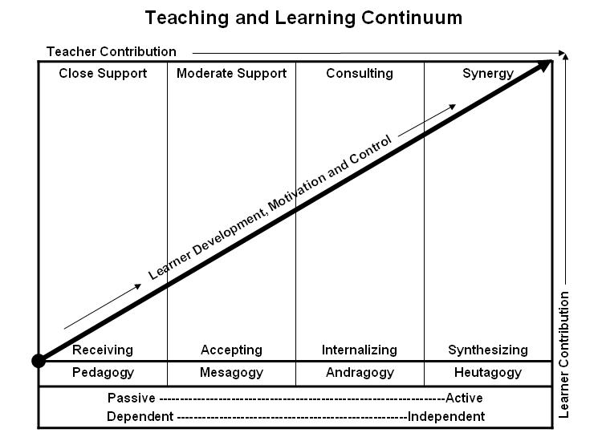

Learner’s Knowledge, Skills and Abilities
Indicator | Key Terms | Description
1 | Limited Knowledge and Proficiency | - Recognize basic information about the subject including terms and nomenclature.  - Students must demonstrate ability to recall information such as facts, terminology or rules related to information previously taught.  - Performs simple parts of the competency. Student requires close supervision when performing the competency.
2 | Moderate Knowledge and Proficiency | - Distinguish relationships between general principles and facts. Adopts prescribed methodologies and concepts.  - Students must demonstrate understanding of multiple facts and principles and their relationships, and differentiate between elements of information. Students state ideal sequence for performing task.  - Performs most parts of the competency with instructor assistance as appropriate.
3 | Advanced Knowledge and Proficiency | - Examines conditions, findings, or other relevant data to select an appropriate response.  - The ability to determine why and when a particular response is appropriate and predict anticipated outcomes.  - Students demonstrate their ability to seek additional information and incorporate new findings into the conclusion and justify their answers.  - Performs all parts of the competency without instructor assistance.
4 | Superior Knowledge and Proficiency | - Assessing conditions, findings, data, and relevant theory to formulate appropriate responses and develop procedures for situation resolution. Involves higher levels of cognitive reasoning.  - Requires students to formulate connections between relevant ideas and observations.  - Students apply judgments to the value of alternatives and select the most appropriate response.  - Can instruct others how to do the competency.  - Performs competency quickly and accurately.
A | Affective Objective | - Describes learning objectives that emphasize a feeling tone, an emotion, or a degree of acceptance or rejection.  - Objectives vary from simple attention to selected phenomena to complex but internally consistent qualities of character and conscience.  - Expressed as interests, attitudes, appreciations, values, and emotional sets or biases.

